

A PROJECT ON

“Profile Management System”

SUBMITTED BY

1. Shivani Deshmukh
2. Sayali Bharambe
3. Komal Hire
4. Nandini Waychale
5. Tanisha Waghmare

In Partial fulfilment of

**Symbiosis Centre for Corporate & Professional Learning**

Symbiosis Skill & Professional University (SSPU)

Kiwale, Pune.

For Academic Year

2024-2025

Under the Project Guidance of

Prof. Vinaya Kulkarni

Department of Engineering

MET Institute of Engineering

Bhujbal Knowledge City

Adgaon, Nashik.

## ACKNOWLEDGEMENT

### Prof.Vinay Kulkarni

### (Symbiosis Trainer)

I wish to express my sincere appreciation to Prof.Vinaya Kulkarni for her Invaluable project guidance and consistent support throughout the seminar. Her expertise and mentorship were indispensable in navigating the complexities of the project. I am profoundly grateful to all the members of the seminar staff whose assistance and resources were crucial in the successful development of the project. This seminar has been the result of dedicated efforts, and I am thankful for the encouragement and support received from all those involved.

### Jaspreet Kaur Kohli

### (TNP Head Officer of Engineering, MET BKC IOE College, Nashik)

I would like to thank her for his qualified guidance, valuable suggestions and constant encouragement throughout the course and project and also for giving her valuable time and help for our documentation

### ABSTRACT

**This profile generation website is a comprehensive tool designed to optimize online profiles for both professional and social media platforms.** It simplifies the process of creating impactful LinkedIn and Indeed profiles by generating content aligned with job requirements and increasing the chances of selection. Users can input their details, and the system analyzes the information to match it with potential job opportunities based on keyword analysis.

**For social media, the website focuses on Instagram and Facebook, helping users create profiles that resonate with current trends and target audiences.** By analyzing popular tags and user behavior, the platform suggests profile enhancements to maximize visibility and engagement. Users can preview the generated profiles and make necessary modifications before downloading them in PDF format.

**A user-friendly interface, complete with a video walkthrough, ensures seamless navigation and understanding of the platform's features.** The website is built using C#, ASP.Net Core, and SQL Server, providing a robust and efficient foundation for profile generation and analysis.

### INDEX

### INTRODUCTION

### OBJECTIVE.

### SCOPE.

### EXCISTING SYSTEM.

### PROPOSED SYSTEM.

### REQUIREMENTS.

### DIAGRAMS.

### FEASIBILITY STUDY.

### SCREEN SHOTS.

### FUTURE ENHANCEMENT.

### CONCLUSION.

### INTRODUCTION

**In the digital age, where first impressions are formed within seconds, a meticulously crafted online profile is paramount.** From professionals seeking career advancement to individuals aiming to build a strong personal brand, the significance of a well-optimized profile cannot be overstated. Yet, creating compelling content that effectively communicates one's unique value proposition across multiple platforms can be a daunting task.

Our profile generation website emerges as a comprehensive solution to this challenge. By leveraging advanced algorithms and data-driven insights, we empower users to effortlessly create high-impact profiles that resonate with their target audience. Whether you're a seasoned professional aiming to climb the corporate ladder, a budding entrepreneur seeking to establish a strong online presence, or an individual looking to expand your social network, our platform offers a tailored approach to profile optimization.

With a focus on LinkedIn, Indeed, Instagram, and Facebook, our platform covers a broad spectrum of professional and social networking needs. Our intuitive interface and user-friendly design ensure that individuals of all technical proficiencies can benefit from our services. By combining cutting-edge technology with a deep understanding of user behavior, we have created a platform that not only generates impressive profiles but also provides actionable insights to help users maximize their online impact.

**Our mission is to revolutionize the way people create and manage their online identities.** We strive to be the go-to platform for individuals seeking to elevate their digital presence and achieve their goals.

### OBJECTIVE

### **Platform Choice**: Enable users to choose between creating profiles for LinkedIn, Instagram, or Indeed.

### **Data Collection:** Display and collect specific information required by the selected platform.

### **Profile Generation:** Generate a profile that meets the specific standards of the platform

### **Proficiency Score:** Access the profile by providing a proficiency score or feedback.

### **Views and Probability**: provide an estimate of the profiles being selected or shortlisted.

SCOPE

1. **Comprehensive Profile Management:** Users can create and manage profiles for multiple platforms (LinkedIn, Instagram, Indeed) from one interface.
2. **Guidance and Optimization:** The website offers guidance on creating optimized profiles, including suggestions and tips for improvement.
3. **Predefined Templates:** Users can use predefined templates to quickly generate professional profiles.
4. **Profile Preview:** Users can preview how their profiles will appear on the selected platform before finalizing.
5. **Feedback and Improvement Suggestions:** The system provides feedback on profile completeness and appropriateness, helping users enhance their profiles for better visibility and selection chances.

### EXISTING SYSTEM

### **Limited Analysis option:** Users frequently encountered restricted tools for analyzing and understanding their profile performance and audience engagement.

### **Security Concern:** The requirement to create accounts on unfamiliar platforms creates privacy and security risks, deterring users from fully engaging in profile creation.

### **Cost Barriers:** Many platforms impose fees for premium features or templates, limiting accessibility for users with budget constraints.

### **Complex Interfaces:** Intricate and counterintuitive design elements hinder the user experience, making profile creation a time-consuming and frustrating process.

### PROPOSED SYSTEM

### **Comprehensive Analytics:** Offer insightful analytics tools to help users understand their profile performance and audience engagement.

### **User- friendly:** Develop an intuitive and user-friendly interface that simplifies the profile creation process and minimizes user frustration.

### **Accessibility:** Ensure that all core features are available for free, removing financial barriers to profile creation and management.

### **Privacy and security:** Offer a secure platform allowing users to create profiles, mandating account creation, and prioritizing data protection.

### REQUIREMENTS

### **HARDWARE REQUIREMENTS:**

### **Processor:** i3 and above processor.

### **Hard Disk:** 16GB for 32-bit OS, 32GB for 64-bit OS.

### **Main Memory:**2GB for 32-bit OS or 4GB for 64-bit OS.

### **SOFTWARE REQUIREMENTS:**

### **Front-End:** HTML,CSS,JAVA-SCRPIT

### **Back-End:** ASP.NET CORE.

### **Database:** Sql Server.

### **Operating System:** Windows 10 or above version

### **Tools:** Visual Studio 2022

### DIAGRAMS

### ER- DIAGRAM.

### CLASS DIAGRAM

### ER-DIAGRAM

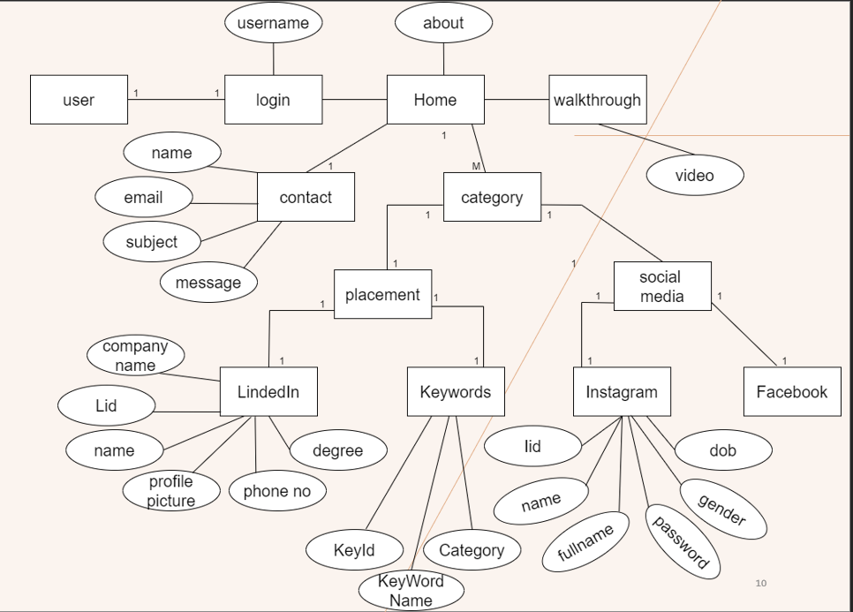

### CLASS DIAGRAM

### 

### FEASIBILITY STUDY

1. **Technical Feasibility:**

• **Data Collection and Processing:** Evaluate the availability and quality of data required for profile generation (e.g., job descriptions, social media trends). Assess the feasibility of processing and analyzing this data efficiently.

• **User Interface:** Evaluate the feasibility of developing a user-friendly interface that allows users to input information and review generated profiles effectively.

• **Algorithm Development:** Determine the complexity of algorithms needed for generating different types of profiles (LinkedIn, Instagram, etc.). Evaluate the availability of existing algorithms or the need for custom development.

### **Economic Feasibility:**

• **Market Analysis:** Identify the target market and assess its size, growth potential, and competition.

• **Revenue Model:** Determine potential revenue streams (e.g., subscription, freemium, one-time fee) and their profitability.

• **Cost Estimation:** Calculate development, marketing, and operational costs. Assess the project's overall financial viability.

• **Return on Investment (ROI):** Estimate the potential return on investment based on revenue projections and cost estimates.

1. **Operational Feasibility:**

• **Project Management:** Evaluate the availability of necessary resources (e.g., human resources, infrastructure) and the project management capabilities.

• **Integration:** Assess the feasibility of integrating the profile generator with other systems or platforms (e.g., social media APIs).

• **Scalability:** Evaluate the system's ability to handle increasing user loads and data volumes.

### SCREEN SHOTS

### FUTURE ENHANCEMENT

### **Dynamic Profile Updates:** Profiles could automatically update based on real-time data and user interactions.

### **AI-Driven Profile** Recommendations: Systems could suggest a profile updates or new information based on user behavior and preferences.

### CONCLUSION

### The Profile Management System presented in this project offers a robust solution to the challenges associated with maintaining consistent and optimized profiles across various platforms. By centralizing profile creation, management, and analysis, this system empowers users to effortlessly cultivate a strong online presence. Through advanced analytics, users gain valuable insights into profile performance, enabling data-driven decisions to enhance visibility and engagement. Ultimately, this system serves as a catalyst for personal branding and professional success in the digital age.

### The potential impact of this Profile Management System extends beyond individual users. Organizations can leverage this technology to streamline employee onboarding, enhance customer relationship management, and optimize recruitment processes. By providing a unified platform for profile management, businesses can foster a consistent brand image and strengthen their online reputation.

### In conclusion, the Profile Management System represents a significant advancement in personal and organizational profile management. Its ability to simplify profile creation, optimize content, and deliver actionable insights positions it as an indispensable tool for individuals and businesses seeking to thrive in the interconnected digital landscape.